

Rick Burke (updated by Peter Simpson)

Abstract

Full information on how to configure and use Device Hub including how to set up dome synchronisation.

Device Hub User Guide

Contents

Introduction 3

Connecting to the Device Hub as a Device 3

Launching the Device Hub as an ASCOM Client 4

Application and Device Settings 4

Application Configuration 5

Device Configuration - Telescope 7

Device Configuration - Dome 7

Device Configuration – Dome Offsets 8

Device Configuration - Focuser 9

Numeric Data Entry 9

Operation 10

Telescope Control – Motion Tab 10

Telescope Control – Direct Slew Tab 11

Telescope Control – Tracking Rates Tab 11

Telescope Control – Capabilities Tab 12

Telescope Control – Static Properties Tab 12

Dome Control – Motion Tab 13

Dome Control – Capabilities Tab 14

Dome Control – Static Properties Tab 14

Focuser Control – Motion Tab 15

Focuser Control – Static Properties 16

Logging Device Activity 16

Appendix A – Telescope / Dome Configurations 17

The dome centre 17

The mount rotational axes intersection 17

Measuring the scope position geometry offsets (all mount types) 18

Determining optical axis offsets for German equatorial mounts (GEM) 18

Determining optical axis offsets for equatorial mounts (not GEM) 19

Determining optical axis offsets for Alt / Az mounts 19

Example Telescope Configurations 19

German equatorial with on-axis telescope 20

German equatorial with off axis telescope 20

Fork Equatorial 21

L-Mount – AltAz 21

T-Mount with dual mount points 22

Fork Mount Alt/Az 23

Appendix B – Document Change History 24

ASCOM Device Hub User Manual

# Introduction

For as long as I have been using ASCOM, POTH has been installed as part of the Platform. It was originally written in 2003 and in 2018 is showing its age. The development tool and the language that it was written in were retired by Microsoft about 10 years ago. It is a testament to the original author and subsequent contributors that POTH is still useful today. However, I decided to dust off my software development skills to write a replacement for the venerable tool. For lack of a better name, I am calling it the ASCOM Device Hub. It supports control of telescopes, domes, and focusers, as POTH does, but is written in C# using Visual Studio 2019.

The internal architecture and the screen design of the Device Hub is significantly different from POTH. It uses the .NET Framework, as do most ASCOM applications that are written today, and the user interface design utilizes Microsoft’s Windows Presentation Foundation (WPF). The use of WPF allows a lot of flexibility to implement clean, powerful, and intuitive user controls and forms. Consequently, the look of the Device Hub may at first be a bit unfamiliar. However, I hope that it allows users to quickly become productive with it.

# Connecting to the Device Hub as a Device

In addition to behaving like an ASCOM client application, the Device Hub exposes a telescope, a dome, and a focuser that other applications can connect to and interact with. This capability provides several advantages.

It allows you to connect the Device Hub to your telescope and your dome. You can then connect to the Device Hub telescope from a planetarium program and use the planetarium program to slew the telescope with the dome following the telescope as it moves from target to target.

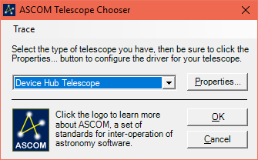It also allows the capability of allowing multiple programs to be connected to each device, even if the device driver only supports a single connection.

To connect to the device hub as a telescope you simply select the Device Hub Telescope from the Telescope Chooser dropdown list.

You should also find Device Hub Dome listed in the Dome Chooser and Device Hub Focuser listed in the Focuser Chooser.

# Launching the Device Hub as an ASCOM Client

The Device Hub can simply be used to simultaneously control a telescope, a dome, and a focuser. In addition, the dome can be slaved to the telescope to keep the dome’s window-on-the-sky centred above the end of the telescope and following the telescope as it tracks and slews across the sky.

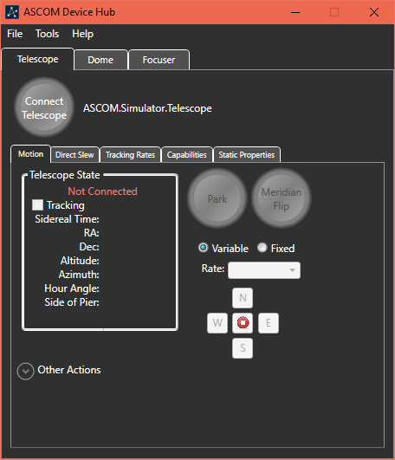When first launched, the Device Hub main window appears like the picture at right:

You can see the menu bar with its File, Tools and Help options across the top of the main window, just below the title bar. The File menu has an Exit item for shutting down the Device Hub. The Tools menu has a Setup item for selecting and configuring the devices and a View Activity Log item for making the Device Hub Activity Log visible. The Help menu item displays this document.

Below the menu bar are the device selection tabs. The Telescope tab is shown at right. Clicking on Dome or Focuser will switch to the view for that device.

When the Device Hub is not visible on the screen, say when it is minimized, it resides in the System Tray. You can display the main window by clicking on the ASCOM icon in the Tray.

# Application and Device Settings

One of the first tasks will be to customize the application and device settings for the Device Hub. To launch the Setup dialog, select Setup from the Tools menu.

The Setup dialog window will appear. The selected tab will be the same as the active device when the Setup dialog was launched unless that device is currently connected. So, if the Telescope device tab was the selected tab in the main window, but no telescope was connected, the Telescope Setup tab will be active when the Setup dialog is first launched.

## Application Configuration

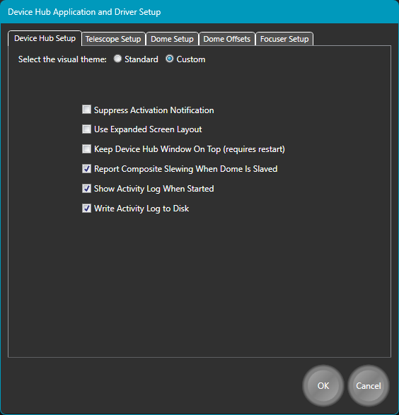Most of the configuration settings are in the device setup tabs, but there are a few that relate to the entire application. They are displayed on the Device Hub Setup tab.

Device Hub supports 2 visual themes. They are labelled Standard and Custom. The Standard theme uses a mostly black on light grey colour scheme with normal control colours and styles, but with some colour changes for emphasis.

The Custom theme uses a mostly white on dark grey colour scheme with custom styles for many controls and other colours for emphasis.

The examples below show both the Standard and Custom visual themes, with the Standard theme on the left.

When you change the selected theme, the change is made as soon as the OK button is pressed.

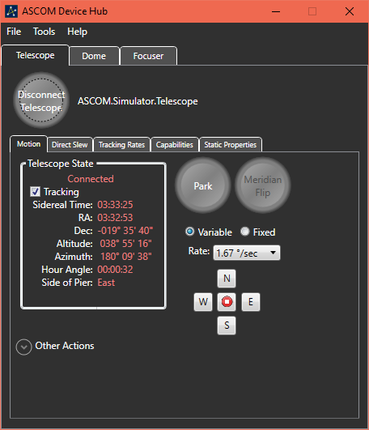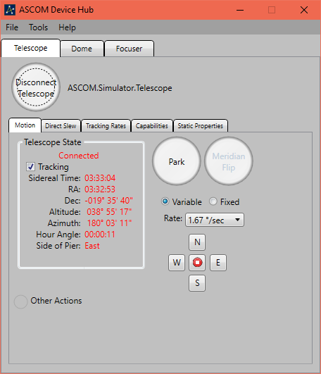The figures below show both the Standard and Custom visual themes.

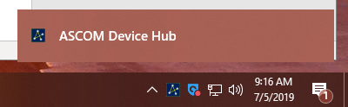When a Device Hub driver is connected from another application, the Device Hub application is placed in the Notification Area, also known as the System Tray. Different versions of Windows manage the Notification area differently. For example, on Windows 10 the icon for the Device Hub is initially shown with a notification window that disappears after a few seconds. Once the window has gone away, the icon may be moved to the notification overflow area. The option to Suppress Activation Notification prevents the notification window from being displayed. It may have a different effect on other versions of Windows where notifications are managed differently.

By default, the device-specific data is organized in separate tabs. This minimizes the screen area that the application occupies but does not allow you to look at the telescope information and the focuser information at the same time, for example. The option to Use Expanded Screen Layout allows you to see one, two, or all 3 devices in a side-by-side arrangement.

When the Use Expanded Screen Layout is selected, the device tabs are replaced by expander controls which occupy the right-hand side of the Device Hub Main window. You can expand the view for either the dome or focuser by clicking on the expander for that device. By default, you can only see 2 devices at the same time. So, clicking on the Focuser Control expander will automatically collapse the Dome Control expander. To see all three devices, simply hold the Ctrl key down when clicking on the expander for the 3rd device.

The figure below shows the application when both the Telescope and Dome are visible while the Focuser pane is collapsed.

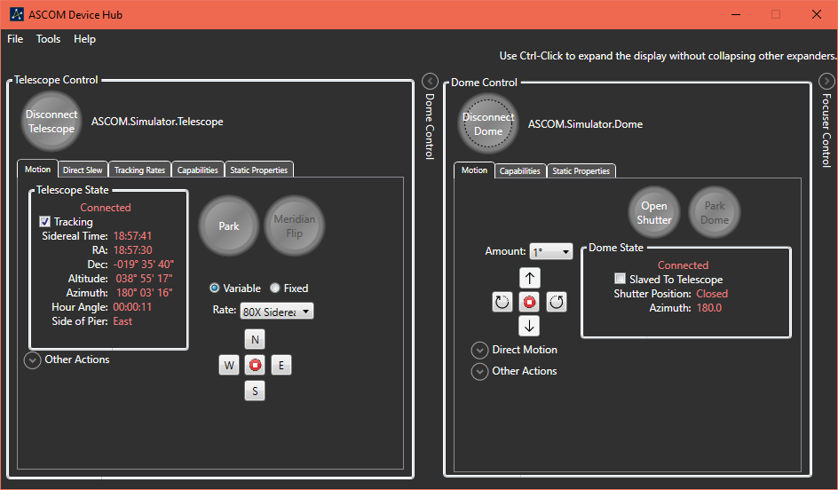

The next configuration setting allows you to choose to keep the Device Hub user interface windows as the topmost windows on the display. When this setting is changed, you must shut down and restart Device Hub for the change to be recognized.

The next setting enables Composite Slewing behavior between the dome and the scope. When this box is checked, the telescope and the dome share the same slewing status when the dome is slaved to the telescope. This behavior allows an application to know that a slew is completed for both the dome and the telescope simply by interrogating the telescope’s Slewing property.

The final two settings enable you to control whether the activity log is displayed on startup and whether activity log messages are saved in a log file.

## Device Configuration - Telescope

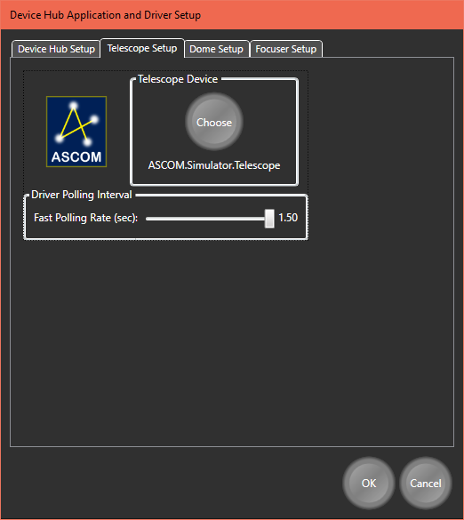One of the first tasks will be to select and configure the devices that are to be controlled by the Device Hub. The Setup item on the Tools menu is used to accomplish this step.

For the Telescope Setup, the only task is to select the telescope driver. Clicking on the round Choose button displays the ASCOM Telescope Chooser to allow you to select and configure the telescope. A slider control is also available to allow you to the interval between polls of the connected driver. The fast update is used when the telescope is slewing. When the slew completes, the rate is slowed to its normal value.

## Device Configuration - Dome

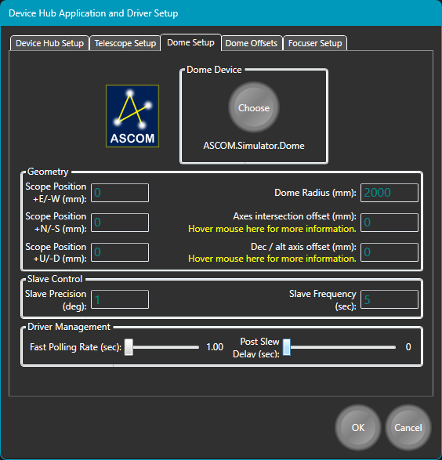To synchronize the pointing position of the dome to the telescope, Device Hub needs information about the configuration of both the telescope and the dome. This is the same information that POTH uses, so if you have POTH correctly configured then you can just transfer the values from POTH to the Device Hub.

The three “Scope Position” values record the three- dimensional distance from the centre of the dome sphere to the point where the mount’s mechanical axes intersect.

Other Dome geometry settings include:

* **Dome radius**: The radius of the dome sphere
* **Axes Intersection Offset**: The distance along the declination / altitude axis from the point where the two mechanical axes intersect to the nearest point on the centreline of the telescope’s optical path. For a German equatorial mount this is often called the GEM Axis Offset.
* **Dec / Alt Axis Offset**: This is the distance from the declination / altitude axis to the nearest point on the optical axis. This will be zero when the telescope lies on the declination axis and non-zero otherwise.

Please see Appendix A – Telescope / Dome Configurations for details on how to measure the required values and examples of different telescope configurations.

The Slave Frequency is a measure of how often the slaving function of Device Hub should consider whether it needs to move the dome to keep the opening over the telescope. These are very dependent on the orientation of the scope and dome themselves. For a telescope with a narrow field-of-view where the shutter is near the end of the telescope, it may be possible to increase the Slave Frequency interval and/ or the Slave Precision (slop) value. Typically, these values should be set as large as possible while keeping the dome’s opening completely over the pointing position of the telescope.

The final two settings are:

* **Fast Polling Rate** - Changes how often Device Hub polls the dome driver for updated status values when the dome is slewing (smaller values increase polling frequency).
* **Post Slew Delay** - A safety feature to ensure that at least the configured number of seconds passes between a slew completing and a subsequent slew starting. This ensures that the dome has time to come to a full stop and prevents sudden changes in rotational direction.

## Device Configuration – Dome Offsets

If you have 2 or more telescopes attached to the same mount, each telescope will have its own “axes intersection offset” and “dec/alt axis offset” offset pair. Multi- telescope support can be enabled on the Dome Offsets tab (Figure 1) where names and unique offsets can be entered for up to 5 telescopes.

NOTE: When multiple telescope support is enabled, you continue to set the three scope position values and the dome radius on the dome setup tab but must now set all optical offsets on the Dome Offsets tab.

When multiple telescope support is enabled, specific telescope offsets can be selected on the Dome operational tab (Figure 2):

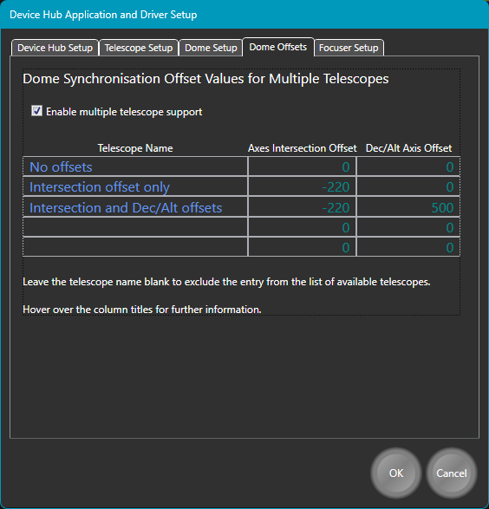 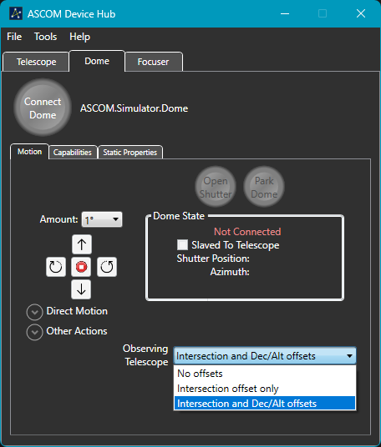

Figure 1 Dome Synchronisation optical offset pairs. Figure 2 - Dome operation tab

## Device Configuration - Focuser

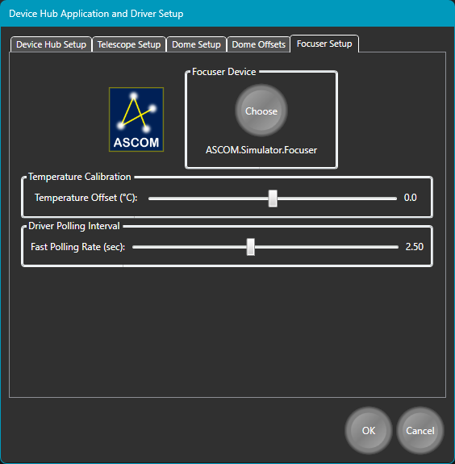There are only three setup parameters for the Focuser. The first is the focuser driver’s identifier. The second is an adjustment value for the focuser’s reported temperature. It is only useful if 1) your focuser reports its temperature and 2) the focuser driver does not provide a method for calibrating that temperature. Changing the value only affects the displayed temperature. It does not affect the focuser’s internal temperature setting or its adjustment of the focuser position with changes in temperature. The value can also be adjusted from the Focuser Motion Tab while the focuser is connected. The 3rd focuser configuration parameter is the polling interval when the focuser is moving.

## Numeric Data Entry

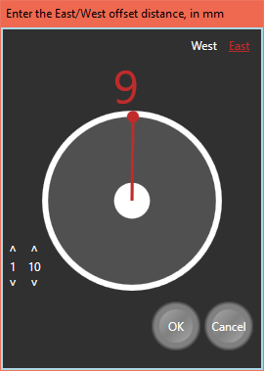When looking at the Dome configuration settings, you may have noticed that there did not seem to be a way to change the values. By clicking on the number (not the identifying text), a pop-up editing window is displayed. This type of editing window is used throughout the application.

The grey and white circle with the red hand in the centre of the dialog is a rotary slider control. The position of the hand corresponds to the value that is displayed above the circle. The value is adjusted by dragging the hand with the mouse pointer. The number above the slider changes as the hand is dragged. The text at the upper right is used to adjust the sign of the number (West is negative). East, underlined in red, is selected. To the lower left of the rotary slider are some up and down buttons which can be used for fine adjustment of the value. They are especially useful when the number has a broad range.

As expected, pressing the Cancel button closes the dialog without changing the value and pressing OK transfers the new, changed value to the parent window.

Some numbers can have multiple components. For example, a declination value has a sign, as well as components for entering degrees, minutes, and seconds. When using the rotary slider to enter a new declination, all the components are displayed above the rotary slider. You can select each component individually and drag the slider’s hand to adjust that value.

Once you have configured your devices, the Setup dialog window can be dismissed. You are now ready to connect the Device Hub with your devices. For the remainder of this document, the ASCOM telescope, dome, and focuser simulators are used as examples.

# Operation

## Telescope Control – Motion Tab

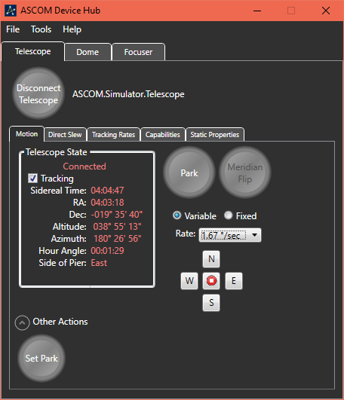Clicking on the Connect Telescope button will immediately connect the Device Hub with the configured telescope and begin communicating with the telescope. This allows the values to be filled in with the data that is being read from the telescope driver.

The numeric values that are grouped in the Telescope State box are continuously updated while the Device Hub is connected to the telescope. In addition, the tracking state can be changed. To the right of the Telescope State group box are buttons to allow you to slew the scope to the Park position and stop tracking and to perform a Meridian Flip (for a GEM mount).

Also to the right of the group box are the movement controls. Two types of movement are supported. When Variable movement is selected, the Rate dropdown list is populated with rates that are reported as being valid by the telescope driver. Movement is accomplished by pressing and holding one of the directional buttons. While the button is pressed, the telescope will move at the specified rate. When the button is released, the telescope will resume tracking at the designated rate, usually the Sidereal rate. When the Fixed rate option is selected, the Amount dropdown list is re-populated with a different list of values. These values are movement amounts and range in value from 1 arcminute to 40 degrees. In this mode, one click of a button moves the mount by the selected amount in the selected direction. Movement does not start until the button is released.

At the bottom of the Telescope State group box is some empty space that is reserved for transient indicators. For example, when the mount is actively slewing, the word “Slewing” will appear in that area. While the mount is moving toward the Park position the word “Parking” will appear in that place. Finally, if the mount has tracked past the meridian and the counterweight bar is pointing above the horizon, the flashing text “Weight Up” is displayed in that area.

The Other Actions expander has a button to set the Park position to the current mount altitude and azimuth. The button is only enabled if the telescope supports the CanSetPark capability.

## Telescope Control – Direct Slew Tab

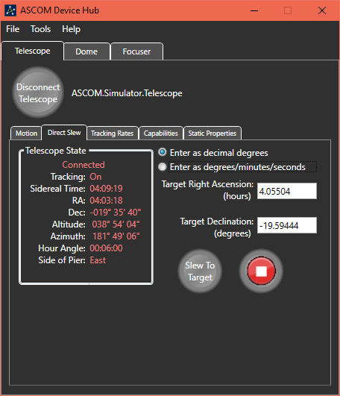The Direct Slew tab provides a way for the user to enter absolute target coordinates and to slew the telescope to those coordinates. As a convenience, a Telescope State group box is also displayed on this tab. However, you must navigate to the Motion tab to change the Tracking flag.

The state of the Tracking flag determines whether the coordinates for the slew are celestial (right ascension and declination) or terrestrial (azimuth and altitude). Tracking must be On to perform a direct RA/Dec slew. If Tracking is Off direct slews will to azimuth and altitude.

Coordinates can be entered either as decimal numbers or in sexagesimal format (degrees, minutes, and seconds).

To change the degrees, minutes, or seconds, you click on the displayed value to pop-up a rotary slider window. To enter as decimal degrees, first select the “Enter as decimal degrees” radio button and enter the new target value in the displayed text box.

When you are satisfied with the target values you can click on the “Slew To Target” button to initiate the slew. The button on the right allows you to immediately abort the slew. While the slew is in progress, the word Slewing is displayed between the two buttons, and the actual pointing position of the telescope is displayed below the buttons.

## Telescope Control – Tracking Rates Tab

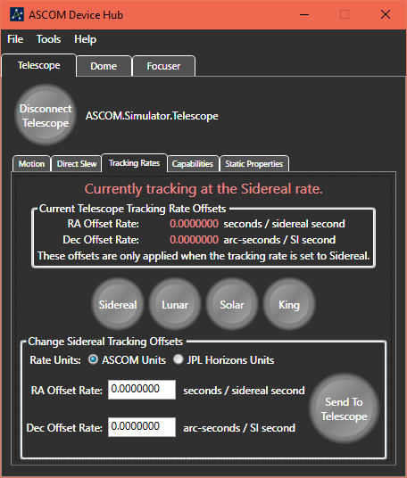The Tracking Rates tab allows you to view and alter the rate at which the telescope moves when tracking. The options allow for tracking at the Sidereal, Lunar, Solar, or King rates, as supported by the connected telescope. In addition, if the driver supports changing the RA and DEC rates, you can enter offsets to the sidereal tracking rate to allow tracking of comets or other Near-Earth Objects. Once these offsets have been sent to the telescope, they will be applied to base Sidereal rate whenever the Sidereal tracking is selected.

One source of offset values for solar system objects is the NASA JPL Horizons web site. Values provided by the Horizons system have different measurement units from those that are specified in the ASCOM specification. As a convenience, you can enter offsets in either unit system. Your entered values will be converted to the units expected by ASCOM before being sent to the telescope.

## Telescope Control – Capabilities Tab

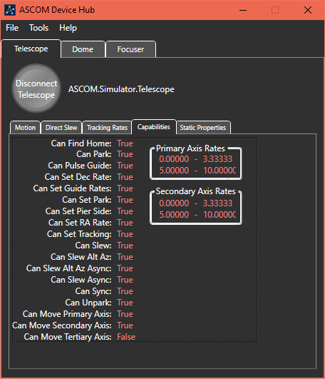To support a wide range telescopes with different abilities, the ASCOM standard provides for properties with indicate which abilities are supported by the driver and the mount. Most of these properties have names that start with Can. These Capabilities are static and are not changeable by client applications. Since they do not change, they are only read at connect time. A complete list of these properties is viewable on the Capabilities Tab.

## Telescope Control – Static Properties Tab

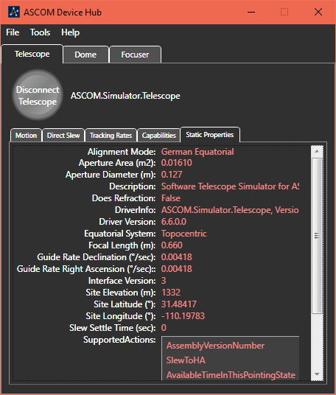There is also a large list of properties with numeric or textual values that do not often change. However, some of these properties can be modified by client applications. These properties are grouped together and displayed on the Static Properties tab page.

Since the amount of information is variable and can exceed the available display space, a vertical scroll bar is provided.

## Dome Control – Motion Tab

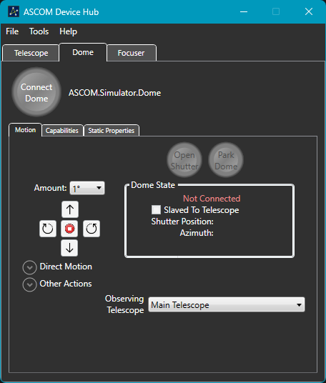 When you connect the Device Hub with your dome, the Device Hub begins communicating with the dome to present the capabilities of the dome as well as its current state. The Dome Motion tab presents the critical up-to-date information and allows you to change the state of the dome and to fully exercise the dome’s capabilities.

For a fully functional dome you can control it in the following ways:

* Open or close the shutter.
* Park the dome
* Send the dome to its home position.
* Adjust the shutter’s altitude.
* Jog the dome in either azimuth or altitude by a selected amount.
* Stop a rotational move or shutter move that is currently occurring.
* Synchronize the dome’s azimuth at a specified position.
* Slave the dome to a connected telescope.

The “Other Actions” control group includes options to override the default algorithm used to calculate the dome azimuth and altitude when slaved to a telescope. *The default algorithm is considered the most functional and reliable option*.

Also, in the Other Actions control group is an adjustment value that is added to the calculated dome azimuth value before that value is used to adjust the dome. This offset may be useful if the dome slit is almost, but not quite, centred over the scope. This value is saved in the Device Hub Dome driver profile and can be changed on the fly. It takes affect with the next dome calculation and can adjust the dome’s azimuth by as much as 20 degrees in either direction.

“Sync To Azimuth” controls are also displayed when the Other Actions control group is expanded. This provides a way to synchronise the dome driver’s position with a known azimuth.

Expanding the Other Actions group cause the Direct Motion group to automatically contract, and vice versa.

To successfully slave the dome to a telescope, the telescope must be connected, and it must be reporting its pointing azimuth and elevation. The dome must be connected and have one of the capabilities CanSetAltitude or CanSetAzimuth be set to True. Of one of these capabilities is set to False then slaving adjustments will exclude that axis. For example, if CanSetAltitude is False then the dome will only be slaved in Azimuth.

## Dome Control – Capabilities Tab

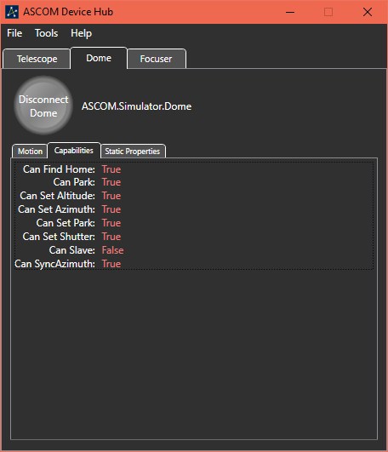Like other ASCOM device types, a dome has capabilities that are specified through a series of CanXXX properties. The values of these properties reflect the abilities of the dome itself as well as the dome driver implementation. For example, an observatory with a roll-off roof would have the CanSetShutter capability set to True and the other capabilities set to False.

The ASCOM Dome Interface Specification allows for a dome to be capable of being slaved directly to a telescope via a hardware connection between the telescope and the dome controller. Since one of the major benefits of the Device Hub is to perform that slaving itself, enabling or disabling hardware slaving is not supported.

## Dome Control – Static Properties Tab

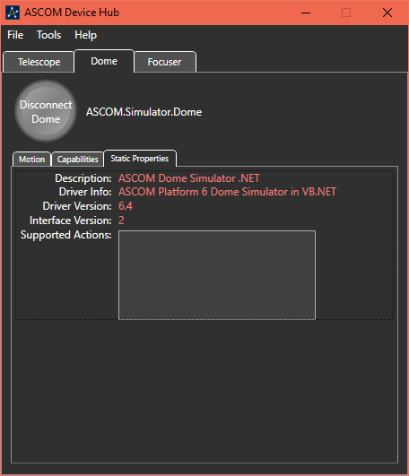In addition to the Capabilities, a dome driver also has a few static properties. These properties and the values for the current version of the Dome Simulator are listed in the screenshot. The values of these properties are provided by the driver and are not changeable by the Device Hub or a client application.

## Focuser Control – Motion Tab

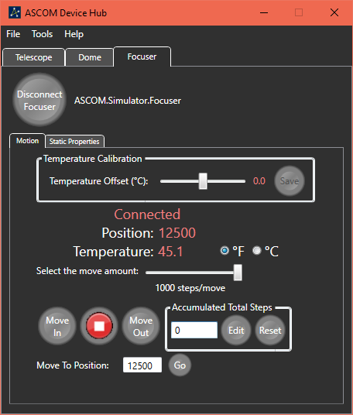When you connect the Device Hub with your focuser, the Device Hub begins communicating with the focuser to present its capabilities as well as its current state. The Focuser Motion tab presents current information from the focuser driver and allows you to interact with the focuser.

Focuser interactions include enabling or disabling temperature compensation (if supported by the focuser and driver) and changing the focuser’s position by using the Move In or Move Out buttons.

The Temperature Compensation checkbox is hidden if the focuser does not support this feature.

The movement amount for the Move In and Move Out buttons is specified by using the slider above the buttons. The movement amounts range from 1 step to 1000 steps, in convenient increments.

If the focuser is an Absolute focuser, you can also change its position by entering a position in the text box that is labelled “Move To Position” and pressing the Go button. The “Move To Position” controls are replaced with a direct movement amount if the focuser operates as a Relative focuser. The label is displayed as “Movement Amount” for a Relative Focuser.

The Accumulated Total Steps controls track the total movement of the focuser since it was connected or changed. By default, the text box which displays the total net movement is set to Read Only. This prevents accidental changes. Clicking on the Edit button allows you to enter an arbitrary value into the text box and changes the button’s label to Lock. Pressing Lock returns the text box state to Read Only. Pressing Reset changes the net move amount to zero without the need to unlock the text box.

Between the Move In and Move Out buttons is a button to abort movement. From a practical standpoint small moves happen so quickly that stopping movement may not be possible, but this button may be useful for aborting a large move.

This screen also provides the ability to change the temperature scale between Celsius and Fahrenheit and to adjust and save the temperature offset calibration value. This is the same value that can be set from the Focuser Setup Tab that was previously discussed. The calibration offset value is always in degrees Celsius. The adjustment range is ±10 degrees.

## Focuser Control – Static Properties

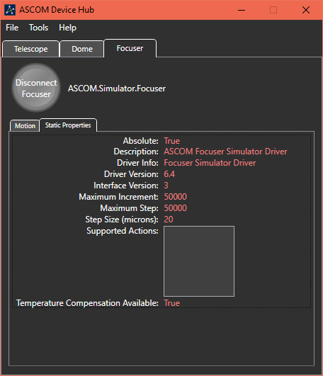A focuser is a simpler device than a telescope, or even a dome, so the list of optional capabilities is much smaller. So, the capabilities are listed on the Static Properties screen. The only optional feature of a focuser, as defined in the IFocuserV3 interface, is whether the focuser supports internal temperature compensation.

One other characteristic of the focuser is whether it operates as an absolute or relative focuser. For more information about this property, please read the ASCOM Developer Help document.

## Logging Device Activity

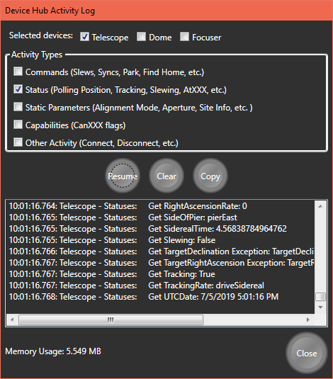The Device Hub can display communications between itself and any connected driver. This is accomplished with the Activity Log. The Activity Log can be viewed by selecting the View Activity Log option from the Tools menu.

Once the Activity Log dialog is displayed you can select which devices to monitor and which classes of messages to display for the selected devices.

You can Pause/Resume the display of new traffic. You can erase all logged messages with the Clear button, and you can Copy all logged messages to the Windows Clipboard. The copied information can then be pasted into any program that accepts text data from the Clipboard.

Use of the Clipboard is the only way to save logged information. It is not automatically saved to a disk-based file. Otherwise, any logged information is lost when the Activity Log is closed.

The capacity of the Activity Log is limited to 125,000 characters. Once that capacity is reached, the oldest data is removed whenever new data is added to stay below the limit.

In addition, the current amount of system memory being used by the Device Hub is displayed at the lower left part of the Activity Log dialog window.

# Appendix A – Telescope / Dome Configurations

Please note that Device Hub supports dome slaving to telescope mounts whose mechanical axes intersect, which includes almost all equatorial, German equatorial and alt/az mounts. It does not support mounts where the mechanical axes do not intersect, which are extremely rare.

## The dome centre

The primary reference point is the geometric centre of the dome sphere. This is the centre of the sphere from which the dome is made. E.g. if the dome is less than a hemisphere, the reference point is not in the plane of the bottom of the dome but is lower than this at the centre of the sphere of which the dome section is a part.

If the dome is more than a hemisphere the centre will be above the plane of the bottom of the dome as shown below.



## The mount rotational axes intersection

This is the point on the mount where its two rotating mechanical axes intersect. Point A is the mount rotational axes intersection point in these two pictures.

 

## Measuring the scope position geometry offsets (all mount types)

These are the three “Scope Position” values in the Device Hub dome geometry section. They record the three-dimensional distance of the point (A), where the mount’s rotational axes intersect, from the geometric dome centre (D):

* **East- West** distance (mm) Positive when the axis intersection is east of the dome centre.
* **North-South** distance (mm). Positive when the axis intersection is north of the dome centre.
* **Up-Down** distance (mm). Positive when the axis intersection is above the dome centre.



## Determining optical axis offsets for German equatorial mounts (GEM)

For a German equatorial in the northern hemisphere, the mount must be in the “Normal” pointing state, which ASCOM defines as being when the telescope tube is physically on the east side of the mount observing a target in the west on the celestial equator.

Now select a target just to the west of the meridian between the zenith and the pole ensuring that the telescope tube remains on the east side.

* The “axes intersection offset” is always non-zero for a GEM.
* The “dec/alt axis offset” will be positive if the telescope optical axis is above the declination axis and negative if it is below. In configurations where the telescope optical axis and the declination axis intersect, this value will be zero.

## Determining optical axis offsets for equatorial mounts (not GEM)

For an equatorial (not German equatorial) in the northern hemisphere, point the telescope at a target on the meridian that is north of the zenith.

* The “axes intersection offset” will be positive if the telescope optical axis is to the east of the mount axes intersection and negative if it is to the west. In configurations where the telescope optical axis and the right ascension axis intersect, this value will be zero.
* The “dec/alt axis offset” will be positive if the telescope optical axis is above the declination axis and negative if it is below. In configurations where the telescope optical axis and the declination axis intersect, this value will be zero.

## Determining optical axis offsets for Alt / Az mounts

For an alt/az mount, point the telescope at a target due south.

* The “axes intersection offset” will be positive if the telescope is to the east of the mount axes intersection and negative if it is to the west. In configurations where the telescope optical axis and the azimuth axis intersect, this value will be zero.
* The “dec/alt axis offset” will be positive if the telescope is above the altitude axis and negative if it is below. In configurations where the telescope optical axis and the altitude axis intersect, this value will be zero.

## Example Telescope Configurations

In these diagrams:

* **Point** **A** is the point where the mechanical axes intersect.
* **Point B** is the point on the declination / altitude axis that is closest to the telescope tube’s optical axis.
* **Point C** is the point on the telescope tube’s optical axis that is closest to the declination / altitude axis.

The distance from point A to point B is the **“axes intersection offset”** and the distance from point B to point C is the **“declination / altitude axis offset”**. In some telescope configurations, points A, B or C may be co-incident and the corresponding offsets will be zero.

The following diagrams show how to determine the offsets for a variety of common mount designs.

### German equatorial with on-axis telescope



* The optical axis is offset from the RA axis so the “axes intersection offset” is non-zero and equal to B – A.
* The declination axis passes through the optical axis so the “dec / alt axis offset” is zero in this case.

### German equatorial with off axis telescope

 

* The optical axis is offset from the RA axis so the “axes intersection offset” is non-zero and equal to B – A.
* The optical axis is also offset from the declination axis so the “dec / alt axis offset” is non-zero in this case and equals C - B.

### Fork Equatorial



### L-Mount – AltAz



This L-mount design supports two observing telescopes. Please note that:

* The axes intersection (point A) is not on the optical axis of either telescope so both telescopes have a non-zero “axes intersection offset” value.
* One offset will be positive and one will be negative.

### T-Mount with dual mount points



This T-mount design has two telescope mounting points:

* The left only requires an axes intersection offset
* The right requires an axes intersection offset and a Dec/Alt axis offset

### Fork Mount Alt/Az



In this Alt/Az mount design:

* The “axes intersection offset” is zero since Points A and B are coincident. This is because the optical axis passes through the intersection of the rotational axes.
* The “dec / alt axis offset” is zero since Points B and C are coincident. This is because the optical axis passes through the altitude axis.

# Appendix B – Document Change History

**Version 1** - Created by Rick Burke

* Original release

**Version 2** – Updated by Peter Simpson - October 2025

* Added details on new logging and display options.
* Revised dome synchronization section to include support for multiple optical telescopes on the same mount.
* Moved the developer technical information out of this user facing document into a separate document in this [link](https://github.com/ASCOMInitiative/ASCOMPlatform/raw/main/Drivers%20and%20Simulators/ASCOM%20Device%20Hub/Documents/ASCOM%20Device%20Hub%20User%20and%20Technical%20Information.docx).
* Added pictures showing the dome offsets.
* Added appendix A with significantly expanded information on how to determine dome / mount geometry settings for use when synchronising the dome.
* Added title page and table of contents.

**Version 3** – Peter Simpson - November 2025

* Made axis description language consistent throughout Device Hub and the text and pictures in this guide.
* Clarified explanations of why the optical offsets are zero or non-zero in each mount design.
* Improved the multi-telescope dome offsets description.
* Revised description of the “not recommended” alternative dome synchronisation calculation algorithm options.

Version 4 – Peter Simpson – 15th November 2025

* Documented new SlewToAzimuth delay option.